Kol Simcha Torah Gazette
For parshas ki savo 5786
Vol 10 Issue 45 (Whole #510) 16 Elul 5786/ August 29, 2026
Printed L’illuy nishmas Nechama bas R’ Noach, a”h
For a free subscription, please forward your request to keren18@juno.com
Past emails can be found on the website ShabbosStories.com under Brooklyn Torah Gazette

The Tragedy That Inspired a Nationwide Shabbat Movement



After losing his 24-year-old son just hours before Shabbat, Moshe Sigdon found strength in the sanctity of the day and we
nt on to establish an organization that teaches the laws of Shabbat to thousands of students across Israel
Moshe Sigdon
For Moshe Sigdon, founder of the Simchat Moshe Rabbeinu organization, Shabbat is more than a sacred day. It is bound to his life through love, faith, and unimaginable personal loss.
One Friday afternoon, just hours before Shabbat, Sigdon noticed a police officer and a social worker walking up the path toward his home. Before they reached the door, his heart already knew why they had come. They were bringing devastating news about his 24-year-old son, Yosef.
Even in the midst of overwhelming fear, one thought remained clear in his mind: Shabbat was approaching.
"I walked down to meet them," Sigdon recalls. "I asked the police officer, 'Brother, are you here because of Yosef?' He said yes. I told him, 'Look, Shabbat begins in two hours. Tell me whether I need to go to the hospital or arrange a funeral.'"
The officer answered with just one sentence: "Blessed is the True Judge."
A Funeral Before Candle Lighting
In the two short hours that remained before Shabbat, Moshe Sigdon arranged his son's funeral.
By sunset, after laying their beloved son and brother to rest, the family had already returned home.
"I gathered my children and said to them, 'If you want to cry, you have every right. Yosef was your brother. But if you want to do something truly meaningful for the elevation of his soul, just as I promised him at his grave, then come with me to the Shabbat table. We'll sing the zemirot, enjoy the Shabbat meals, and honor the holy day properly.'"
The family agreed.
The Shabbat table was set as usual.
"People thought I must have taken medication or received some kind of injection," Sigdon says. "But no. It was simply the power of Shabbat that gave me the strength to endure."
Turning Personal Tragedy Into a National Mission
Despite his profound grief, Sigdon did not stop with preserving his own Shabbat observance. Instead, he made a life changing decision: to dedicate himself to helping Jews throughout Israel observe Shabbat properly.
"I received a disc from Rabbi Zamir Cohen containing eighteen hours of lessons on the laws of Shabbat," he says. "I listened to it while driving across the country. It just kept going, teaching one halacha after another. I realized something important: How can we keep Shabbat the way G-d wants us to if we don't actually know its laws? The Jewish people must address this."
Bringing the Laws of Shabbat Into Schools
To spread practical knowledge of Shabbat, Sigdon founded Simchat Moshe Rabbeinu, an organization devoted to teaching the laws of Shabbat in schools throughout Israel.
"We work with approximately 270 schools representing every segment of the religious community," he explains. "The program is designed for fifth and sixth grade students. Each child receives a Shabbat law workbook that we publish, studies it, and takes examinations."
The highest scoring students are invited to a national public competition held at the Jerusalem International Convention Center.
"Many prominent rabbis attend these examinations. Rabbi Ovadia Yosef, of blessed memory, came even during the final two years of his life, despite being very frail."
Preparing for Redemption Through Shabbat
Sigdon believes that strengthening Shabbat observance is one of the Jewish people's greatest spiritual responsibilities.
"Our Sages taught that keeping Shabbat brings the redemption closer. That means every rabbi should strengthen Shabbat observance within his own community and encourage educational institutions to teach its laws to students of every age."
He also believes parents share this responsibility. "Parents should ensure that their children learn the laws of Shabbat and ask their schools to include structured Shabbat education."
A Childhood Shaped by Shabbat
Sigdon grew up in Israel's immigrant transit camps, where his love for Shabbat first took root.
"Shabbat was always precious to me," he says. "G-d tested me through Shabbat when He took my son on a Friday afternoon. But people don't realize how powerful Shabbat truly is."
He then shares an extraordinary experience.
My youngest daughter once dreamed about Yosef. In the dream, he was glowing with radiant light. She asked him whether everything we had done to strengthen Shabbat had really helped him."
According to Sigdon, Yosef replied: "You have no idea how precious Shabbat is in the World to Come. Because of what you did, all the heavenly chambers are open before me."
A Treasure Worth Protecting
For Sigdon, the message is simple.
"Shabbat is a priceless treasure, but we cannot observe it properly without learning its laws. Jews work hard before Shabbat, buying meat, fish, watermelon, and everything else needed to honor the day. Yet too often, they neglect the very laws that make Shabbat holy."
"Isn't that a shame? Let us learn the laws of Shabbat and bring joy to our Creator."
Reprinted from the current website of Hidabroot.com.
The Lesson of the Bikurim:
A Jew’s Empathy for
the Lack of Another Jew
From the Teachings of the Lubavitcher Rebbe
Rabbi Menachem Mendel Schneerson, Zt”l
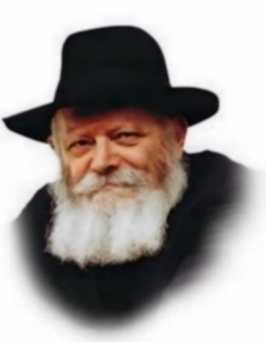

The opening words of the Torah portion, Ki Tavo, outline the precept of bikurim, the first ripe fruits which were to be brought as an offering of thanks to G-d for giving us the Land of Israel.
One of the points emphasized by the commentators on these opening verses is that as long as the entire Land was not yet in the possession of the Jewish nation, the individual Israelite who had already received his portion of the country was not required to bring the bikurim offering.
The bikurim offering was an expression of overwhelming gratitude to G-d for coming into the Holy Land and enjoying its fruits. For the individual who had already entered the land, taken possession of his portion and enjoyed the fruits, was it not ungrateful to wait until the end of the fourteen years of conquest and apportionment to the tribes before bringing bikurim? Why were these individuals not required to offer bikurim to thank G-d for the good He had already bestowed upon them?
Here, however, is where the Torah's great teaching of ahavat Yisrael (love for another Jew) comes into play: The bikurim offering was to be brought as an expression of complete, perfect joyousness. This is evident from several laws of bikurim, e.g. they were to be brought only from the fruits with which Israel was praised; they were to be brought only once a year-because something which is repeated during the year does not evoke as much joy.
But all our people are interconnected, and so long as even one single Jew remained who had not yet taken possession of his inheritance in Israel-however lowly and "unimportant" that person may have been-then there was something missing from the goodness and pleasure experienced by all his brother Jews. For all Israel is as one. Empathy for another's lack is to reach the point of feeling the emptiness within oneself. Since the joy of those who had already taken possession of their own portion was incomplete (because of their brother's lack), they could not bring bikurim!
Ki Tavo is always read close to the 18th of Elul. This date is the anniversary of the birth (in 1698) of the Baal Shem Tov, founder of Chasidism in general, and of the birth (in 1745) of Rabbi Shneur Zalman of Liadi, founder of Chabad-Lubavitch Chasidism. These two great luminaries of Chasidism made ahavat Yisrael the touchstone of their teachings and the exemplary feature of their own personal lives.
The Baal Shem Tov's foremost disciple, Rabbi Dov Ber of Mezritch stated, "If only we could kiss the Torah scroll with the same tender affection that my master, the Baal Shem Tov, would embrace the small children he brought to cheder." And Rabbi Shneur Zalman's followers lived with the motto, "The piece of bread that I have is yours just as it is mine," and they would say the word yours first, "...yours just as it is mine."

Reprinted from the Parshat Ki Savo 5763/2003 (Issue #786) email of L’Chaim, a publication of the Lubavitch Youth Organization in Brooklyn, NY. Adapted from the works of the Lubavitcher Rebbe.

Rav Avigdor Miller
On What is the Purpose
Of Antisemitism

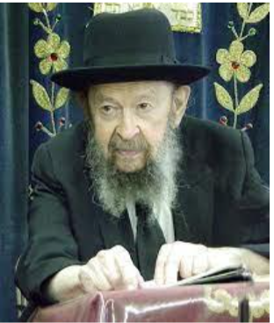

QUESTION: What is the purpose of antisemitism?
ANSWER: In short, the answer is that antisemitism is a miracle. It’s a barrier, a wall that the Almighty sets up when he sees that a wall is needed. When there is too much fraternization between Jew and gentile, and it’s all going one way—it means that the Jews are traveling across the wall in that direction—so the wall has to be made higher. And antisemitism is that wall that helps keep us aloof and separate. That’s the reason why this force was created.
Now, there are more purposes to that but briefly, that’s the main purpose. The principle is, separate! הן עם לבדד ישכון – A nation that dwells alone, ובגוים לא יתחשב – we have no business with other nations. That’s Hashem’s policy with us and therefore in order to keep us apart from the nations of the world, Hashem creates a wall between us and them and that wall is antisemitism.
It must be at all times—nothing to do with our good behavior or bad behavior—in order to protect us from fraternization with the umos ha’olam. Only that He raises the wall according to how much it’s needed.

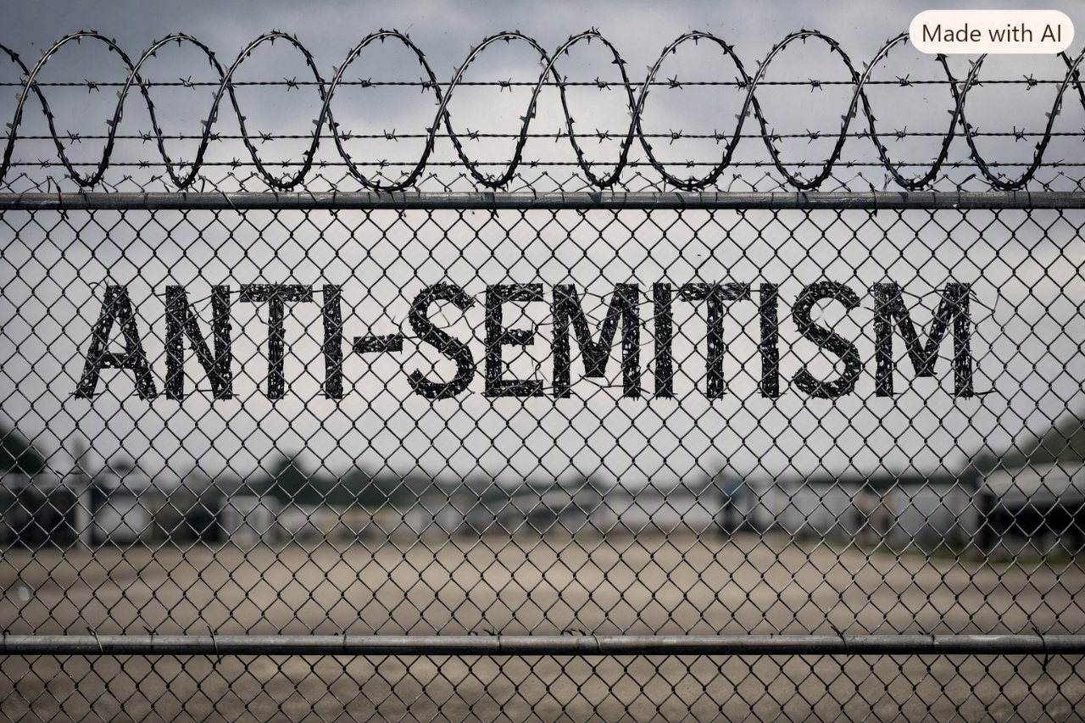
QUESTION: But can’t we say that antisemitism is caused because of jealousy of the Jews, that we’re a successful and often wealthy nation? Isn’t there some mehalech that we can explain the hatred in a more natural way?
ANSWER: That’s not enough of a reason. It’s not enough, because there have been classes of gentiles who have been successful and wealthy and they have not been greeted with such a wave of animosity as the Jews. For example, there was a class of usurers licensed by the pope called the Corsini. And when the Jews were driven out of England, the Corsini and they became the usurers. Now, they weren’t beloved by the English. They were much worse, and the English said, “Would that we had back the Jews now. We’re suffering more from the Corsini.” The English tried to get rid of them, but they had the protection of the pope. They were the pope’s own usurers.
But even though the English suffered from them worse than they did from the Jews, the hatred that was generated against the Jews was not evident then against them.
Now, they have tried to analyze this. You know how much money has been spent on surveys of this subject? To no avail. They come up at the end with a big question mark. And the truth is it’s a nes. It’s a miracle. It’s hashgachah pratis. Hakadosh Baruch Hu is doing it.
Reprinted from a recent email of Torah Avigdor based on an April 1974 question-and-answer session from a classic Thursday night hashkafah lecture of Rav Avigdor Miller, zt”l.

Thoughts that Count
for Our Parsha
Since you did not serve the L-rd your G-d out of joy and gladness of heart...you shall serve your enemies (Deut. 28:47).
Joy holds such importance in the service of G-d. The implication of the verse is that the severe punishment of serving one's enemies comes only as a result of joy lacking from our G-dly service. It is as if joy in our service awakens joy in G-d Himself and annuls all harsh judgments. (Rabbi Shneur Zalman)

I have not transgressed any of your commandments neither have I forgotten (Deut. 26:13).
Why were two such similar statements necessary? To teach us that it is possible to fulfill a commandment and at the same time forget it. This happens when one fulfills it without intent-while the mind is focused on other things. (Sfat Emet)

And G-d has avouched you this day...to keep all His commandments. (Deut. 26:18)
Is it not already stated in the previous verse, "and to keep His laws and commandments"? Rabbi Levi Yitzchak of Berditchev explained that the verse "and to keep all His commandments" here refers to G-d Himself, Who is also obligated to keep His commandments to us, especially the mitzva of "you shall not delay in paying your hired laborer," and He must give us all life and sustenance.

Reprinted from the Parshat Ki Savo 5763/2003 (Issue #786) email of L’Chaim, a publication of the Lubavitch Youth Organization in Brooklyn, NY.
The Jihadist Who
Converted to Judaism
By Yehudis Litvak

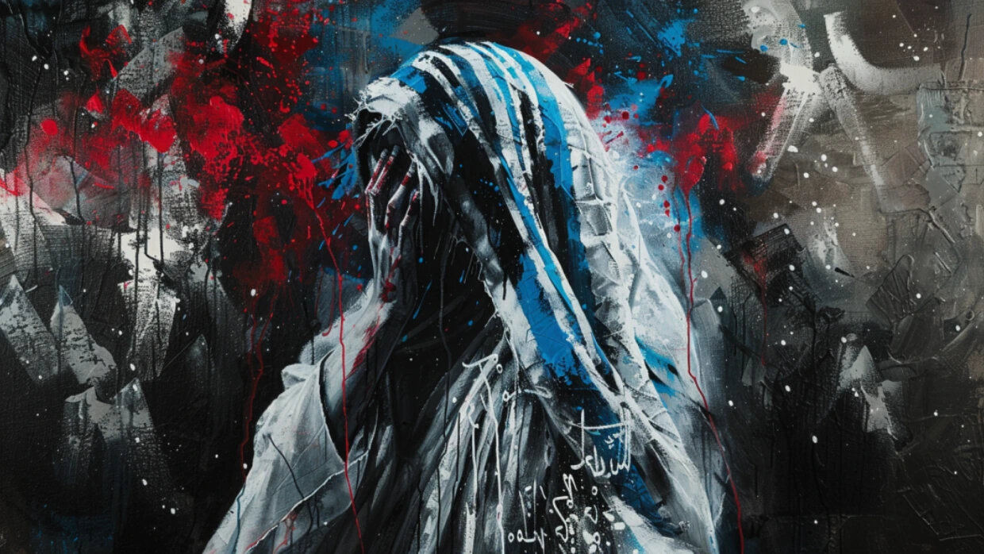
Yaron Avraham’s Journey from a Shahid in Training to a Committed Jew.

Growing up in a religious Muslim Arab family in Lod in the 1980s, Yaron Avraham was exposed to crime and violence from a young age. As a seven-year-old, he was sent to distribute drugs to his family’s customers in the neighborhood.
At age nine, things went from bad to worse. Yaron’s 16-year-old sister, whom he’d been the closest with out of his 17 siblings, was murdered by his older brothers in a “family honor” killing. She came home late one evening, and that was too suspicious in these extremist Muslim circles. The murder took place at home, in the room next to Yaron’s, and he heard everything.
The family covered up the murder, and to this day, Yaron’s sister is listed as missing in Israeli government records. But the family had a problem. Yaron began asking questions. He wanted to know where his sister went and what his brothers did to her.
Sensing danger, Yaron’s family decided to send him far away from home, to a mosque that doubled as a boarding school in Gaza. “I don’t know if they knew about the education there, or if they simply wanted to get rid of me,” says Yaron. “I found myself in a mosque – one of the most extreme in Gaza.” The education he received there can only be termed child abuse.
Shahid Training
The mosque’s explicit objective was to turn its students into shahids – martyrs ready to sacrifice their lives for Islam’s religious war, Jihad. “It’s a very cruel education,” says Yaron. “Most of it is structured around death. You were forced to remember every morning that your ultimate goal was to return to the ground as quickly as possible. So, it’s walking in cemeteries, being taken to see terrorists killed by the IDF, kissing them – their hands, their feet – to get inspiration, so we’d want to be killed like them.”
There were no desks or beds in the mosque. Four hundred students slept on the ground to get used to the idea of returning to the ground. During meals, they sat on the floor and ate with their hands. Normal childhood activities, like listening to music, were strictly forbidden. There was no room for individuality. Children who were naturally left-handed were forced to eat with their right hands. Most of the day was spent memorizing the Koran.
The highlight of this education, recalls Yaron, was lying in an open grave in the middle of the night while their teachers would stand over them and read verses from the Koran “to evoke the feeling of the moment of ascension, when the soul rises to Heaven… Personally, it took me almost 15 years to get over that experience.”
Any misbehavior was strictly punished. “There was an incident of two children, 13-year-olds, who were suspected of being intimate with each other,” says Yaron. “They pulled us out of bed at 4 a.m., explained what these boys were accused of, and cut off their heads right in front of us.”
Yaron stayed in the mosque for five years. “I never got used to it,” he says. “It only got harder. I didn’t connect to this education.” Yaron noticed contradictions in his studies and began asking questions.
A central theme of Yaron’s education was hatred of Jews. “They told us that Jews are bloodthirsty vampires who rob, rape, murder, steal. They told us that the Jew is the lowest creature, enemy #1, impure.” Killing Jews was considered a most admirable goal.
Of all the students at the mosque, Yaron was the only one who had been outside of Gaza and who had actually seen Jews. For his many questions, Yaron was severely beaten. Then his teachers transferred him to a different mosque, in Yatta, near Hebron, in the hopes of turning Yaron into a real shahid. He spent a 18 months in Yatta where the education was even more cruel than in Gaza.
Escape
At age 16, Yaron managed to escape from the mosque.
At first, he went home to Lod but his family was not happy to see him. His older brothers told him that it wasn’t his home anymore and that they didn’t want him there. His mother, an obedient Muslim woman, did not say a word in his defense. His father didn’t get involved either.
two weeks, Yaron escaped from home and went to live in a Muslim cemetery. “This was the only place where I felt safe,” he says. “Nobody was going to look for me in a cemetery. I went out to look for food at night, in garbage cans, scraps, things like that.”
Yaron spent ten days at the cemetery. One night, as he was searching for food, Yaron met a Jewish man who offered to help him. “He saved my life,” says Yaron. “He gave me money and put me on a bus to Eilat.” There, another Jewish family took him in. They helped him get in touch with an organization for at-risk youth in Tel Aviv.
“I discovered something that was completely new to me,” Yaron says, “something that in Judaism, and in general in the western world, is taught from a young age – the sanctity of life. I discovered that I am allowed to live, I am allowed to dream. The Jews took me in. They didn’t ask questions. They didn’t care if I was Arab or not. They just let me stay in their home. They gave me food. They kept me safe from all my brothers. They kept me safe from dangers.
These people instilled in me confidence, a certainty that I am a human being, like any other. They taught me to learn, to grow, to be human, to go to the beach, to have friends. I didn’t know how to behave with ordinary people, how to have a conversation with them. I didn’t even know how to hold a knife or a fork. They had to teach me everything, starting from scratch.”
Army service
Grateful to the Jewish people for all the help he’d received, Yaron decided to enlist in the Israeli army. “This was the only thing I could do to in return for the good that [Israeli Jews] did for me,” he says.
At first, the IDF recruitment office rejected him. “But I don’t give up easily,” says Yaron. Eventually, he enlisted and served in the elite Givati unit.
During his army service, Yaron was sent to Gaza. He was impressed with his fellow soldiers’ conduct toward the local residents. Israeli soldiers were nothing like the bloodthirsty monsters portrayed by his teachers. Just the opposite – they were ethical and principled. They would share food and drink with Gazan families. They didn’t kill anyone for no reason.
Once, Yaron’s unit came close to the same mosque where he was horribly abused only three years earlier. It was a difficult moment for Yaron. He desperately wanted to take revenge on his tormentors.
When Yaron saw the same teacher who had cruelly beaten him, he couldn’t hold himself back. “I raised my gun and was about to shoot,” he says.
Yaron’s commander grabbed his gun away from him. He spoke to him and calmed him down.
“It’s an amazing thing,” says Yaron. “The person who saved the life of the one who taught me to kill Jews just because they are Jews – he is an officer in the IDF.” Later, in a heart-to-heart conversation, this officer taught Yaron to “sanctify life, not death. That was when I decided that I want to join this nation.”

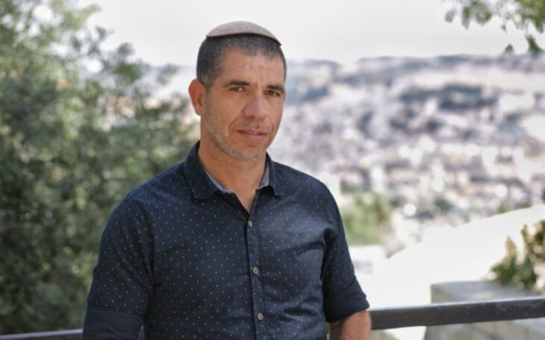
Yaron Avraham

It was a long journey. After the army, Yaron returned to Tel Aviv and studied to become a chef. Then he went to what he describes as “Heaven on earth” – Yeshiva Machon Meir in Jerusalem where he underwent the conversion process to become Jewish.
Today, Yaron is married and the father of three daughters. He is a popular speaker and has been invited to speak at colleges and universities, as well as various communities in Israel. Yaron is currently working on a book about his experiences.
“As I learned more about Judaism, I began to understand that all the darkness I went through in my life can be transformed into great light. Many people go through hard times and come close to despair, but through hearing my story they find strength and perseverance.”
Fighting for the sanctity of life
Shortly after the brutal Hamas terrorist attack, Yaron shared, “What happened on October 7th is not even the height of their cruelty. They have many more methods. They hate Jews simply because they are Jews. There is no other reason. They say it’s because of the occupation, but in the Koran it is written that the Land of Israel was given to the people of Israel. We were taught blind hatred with no rhyme or reason. It’s just a religious matter.
“I literally left the grave. I am alive, and I have a mission – to bring the truth to light. When I was in the army, and even now, in the reserves, I stand for the people who sanctify life. I want to fight for the truth.”
Yaron warns the world about the threat of radical Islam, which, he says, “is also spreading in Europe and other places. For years I have been warning anyone who would listen that they are capable of the horrors we saw them commit [on October 7th]. People didn’t believe me. They told me I was exaggerating.
“People think this is Israel’s problem. People should thank Israel, because Israel is fighting the war for the whole world. Israel is fighting for the sanctity of life.”

Reprinted from the current website of aish.com

The Bad Influence
of the Egyptians

■ וירעו אתנו המצרים – The Egyptians mistreated us (26:6). The word וירעו is from the root of רע , bad, i.e. the Egyptians made things very bad and difficult for the Jews by mistreating them. If so, the posuk should have stated וירעו לנו , they mistreated us, rather than אתנו , which translates literally as “they made us bad.” Maayanah Shel Torah explains that the Egyptians influenced the Jews in Egypt with their abominable behavior to such an extent, until they made the Jews into רעים , badly behaved people.

■ היום הזה נהיית לעם – This day you have become a People (27:9). R’ Shamshon Rafael Hirsh explains that today, when you accepted on yourself with an oath to fulfill the Torah, then you became a nation. The Jews’ nationhood did not start when they acquired their own land or language. It began with their commitment to fulfill the Torah. (Mayaanah Shel Torah)

Reprinted from the Parshas Ki Savo 5786 email of The Weekly Vort.

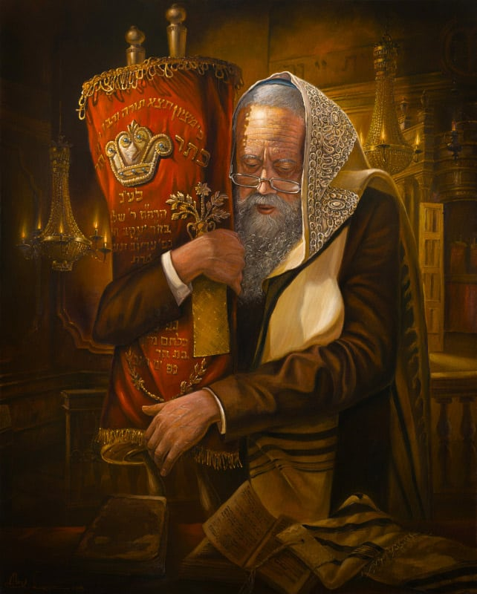
Artwork by Alex Levin

